ASSIGNMENT 3

Q1. Connect one PC with another PC

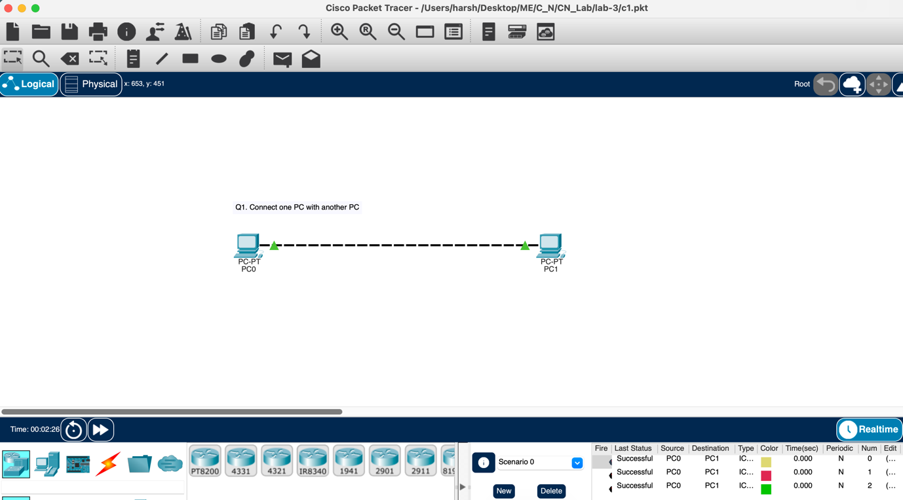

Q2. Connect a PC with Router Ethernet port.
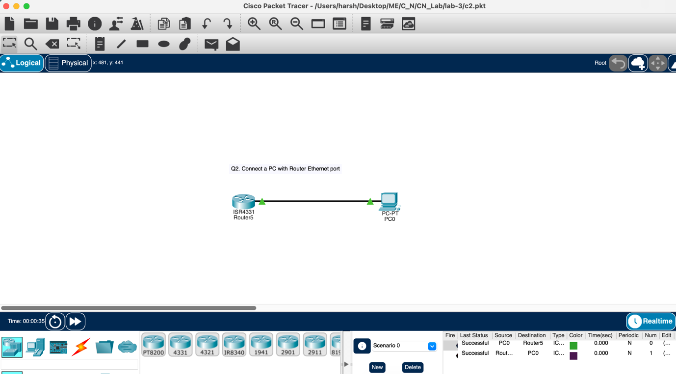

Q3. Create a network of 2 PCs.
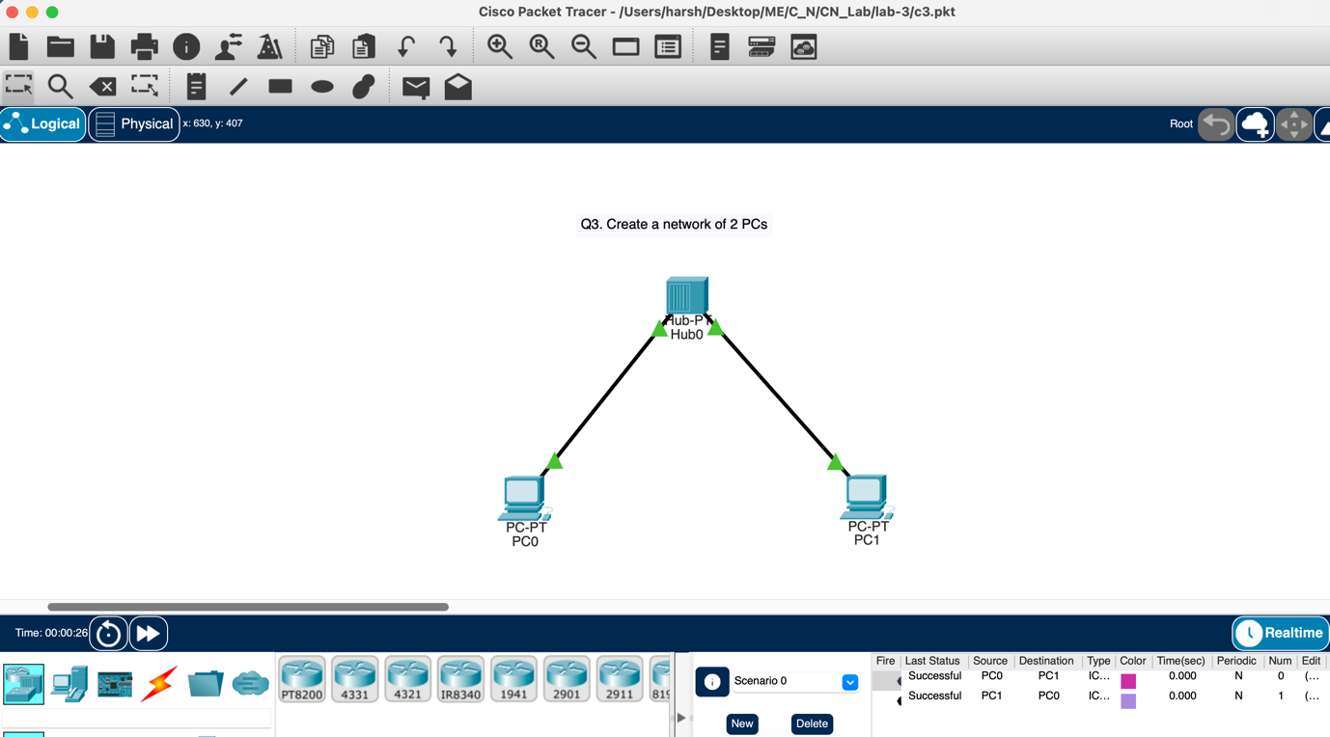

Q4. Connect 2 PCs with a Switch.
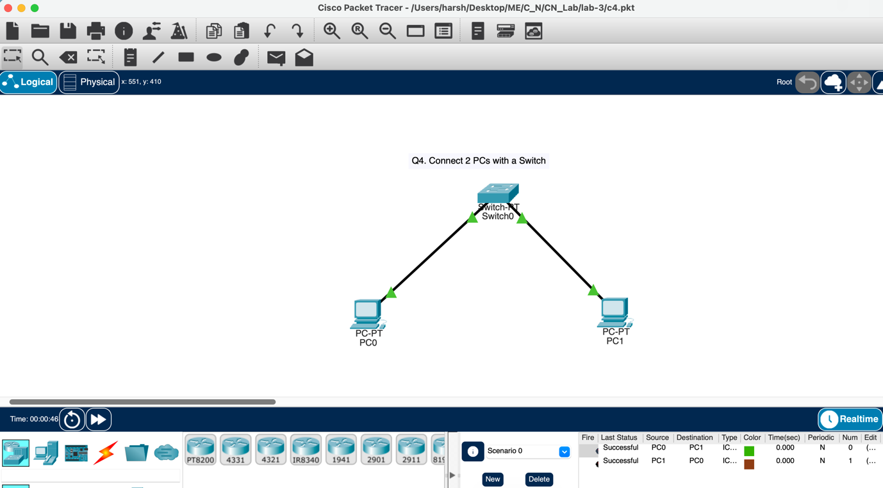

Q5. Create BUS topologies
a)
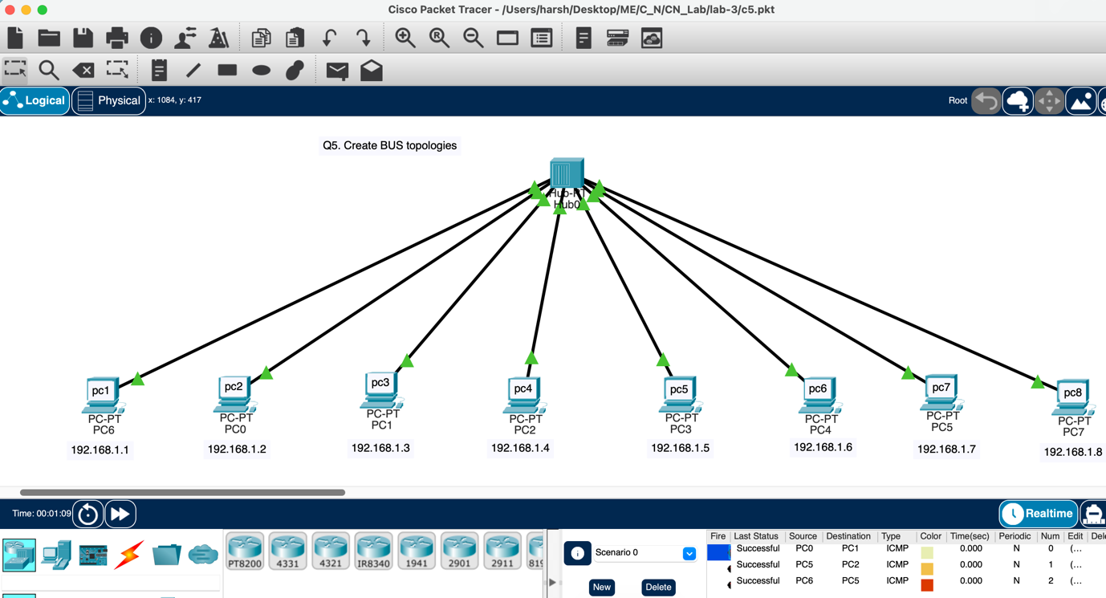

b)
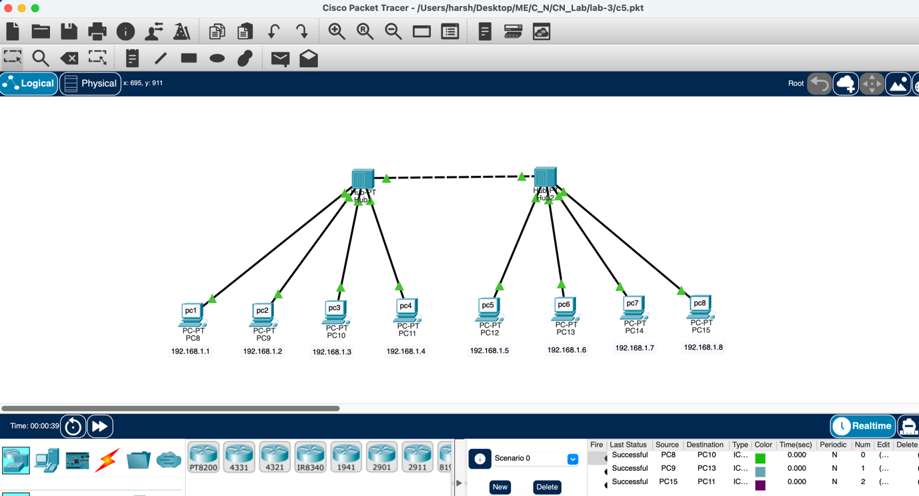

Q6. Create the following Ring Topology.
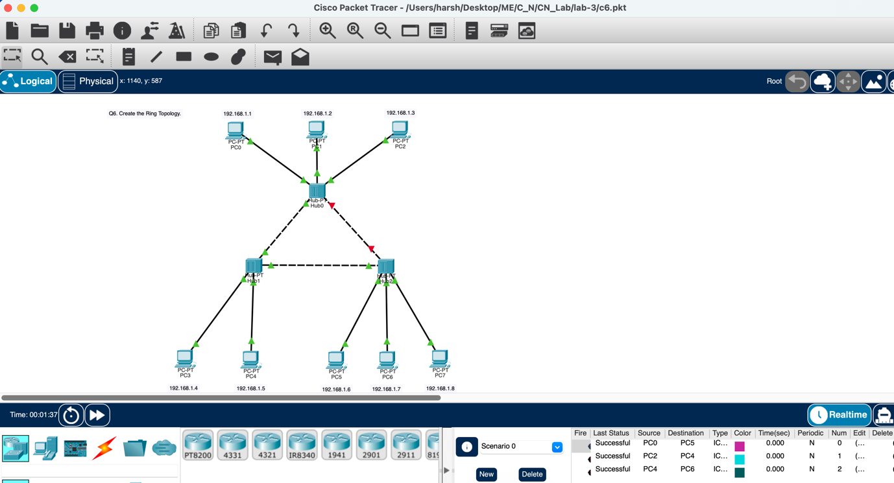

Q7. Create the following Ring Topology
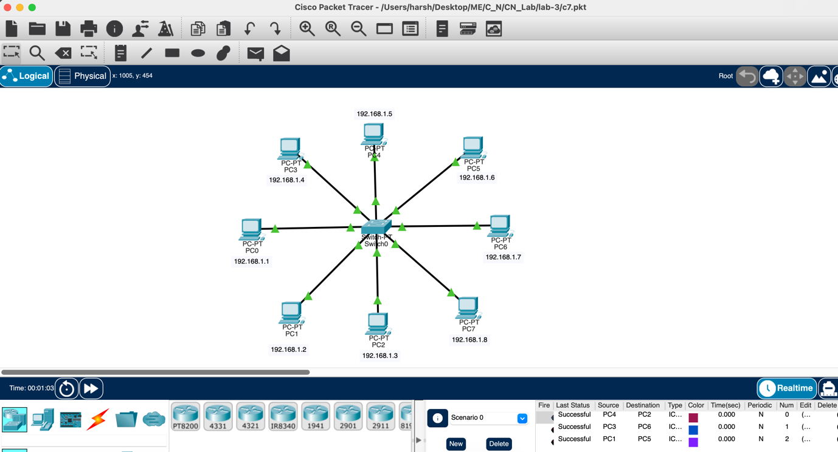

Q8. Create the following Tree Topology.

